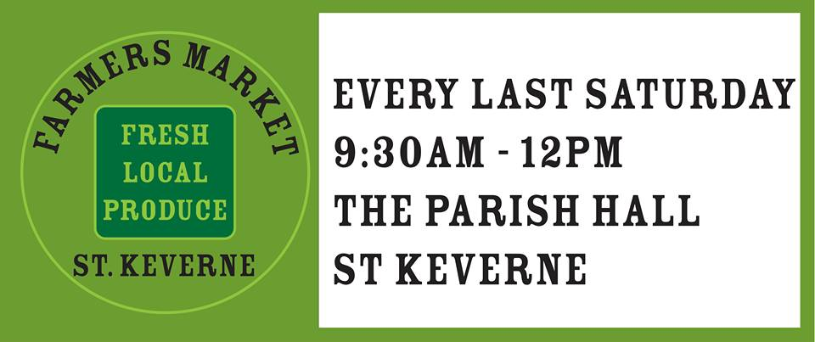
1 Trenoweth Farm Cottages, St Keverne, Helston, Cornwall, TR12 6QQ
stkfarmersmarket@gmail.com

1st November 2017

Mr Hugh Richards
Coverack Christmas Tree Lights
Coverack
Helston
Cornwall

Dear Hugh

Donation for Coverack Christmas Lights

We run the Farmers Market in the Parish Hall every month and it is a non-profit organization with the stallholder fees going to local charities within the Parish. This year Coverack Christmas Lights is one of our chosen charities therefore I enclose a cheque for £150 towards the fund.

Yours sincerely

Marianna Fuller
On behalf of Marianna, Kellie and the Farmers Market Team

