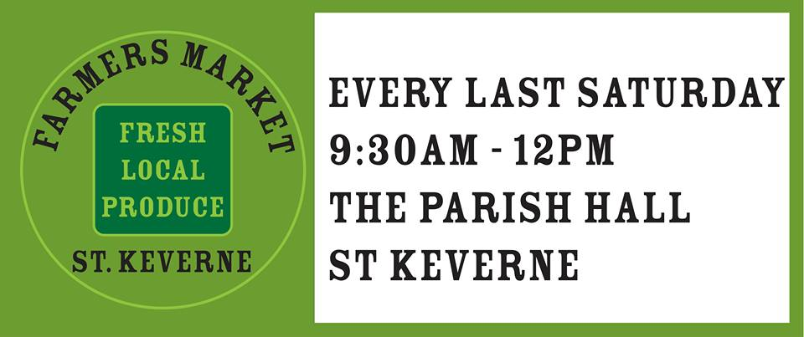
1 Trenoweth Farm Cottages, St Keverne, Helston, Cornwall, TR12 6QQ
stkfarmersmarket@gmail.com

15th November 2018

Claire Smitherham
St Keverne Pre-School
St Keverne
Helston
Cornwall

Dear Claire

Donation for the Pre-School

As you know we run the Farmers Market in the Parish Hall every month and it is a non-profit organization with the stallholder fees going to local charities within the Parish. This year St Keverne Pre-School is one of our chosen charities therefore I enclose a cheque for £100 towards the fund.

Yours sincerely

Marianna Fuller
On behalf of Marianna, Kellie and the Farmers Market Team

